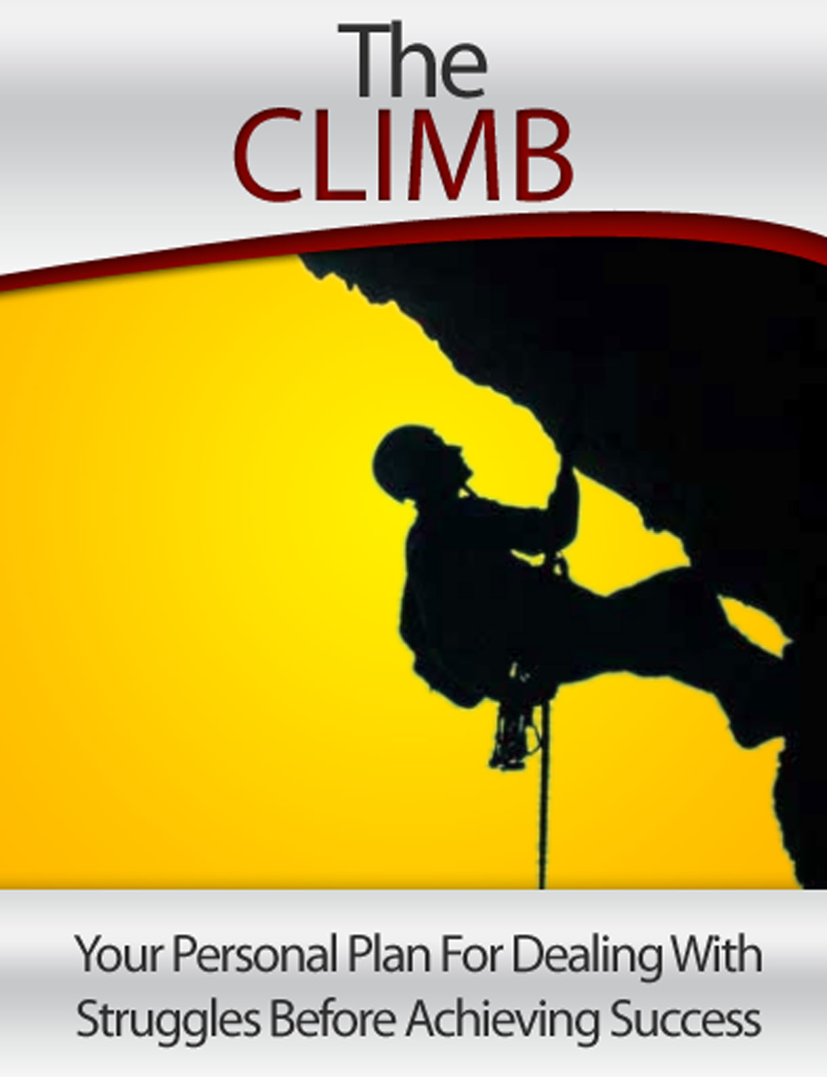

LIMITS OF LIABILITY / DISCLAIMER OF WARRANTY:

The Authors has strived to be as accurate and complete as possible in the creation of this manual, notwithstanding the fact that he does not warrant or represent at any time that the contents within are accurate due to the rapidly changing nature of the Internet.

While all attempts have been made to verify information provided in this publication, the Authors assume no responsibility for errors, omissions, or contrary interpretation of the subject matter herein. Any perceived slights of specific persons, peoples, or organizations are unintentional.

There are no guarantees of income made. Readers are cautioned to reply on their own judgment about their individual circumstances to act accordingly. This book is not intended for use as a source of legal, business, accounting or financial advice. All readers are advised to seek services of competent professionals in legal, business, accounting, and finance field.

Screen shots seen in this manual are from publicly accessible files and web pages and used as “fair use” for reporting purposes and to illustrate various points mentioned herein. Texts and images available over the Internet may be subject to copyright and other intellectual rights owned by third parties.

Table of contents:
Tables of contents …............................................................................ 3
The Ultimate Success Formula …........................................................ 4
Committed to What You Want …......................................................... 12
Taking 100% Responsibility In Your Life …......................................... 13
The Power of Choice …...................................................................... 15

1 - The Ultimate Success Formula

In life, things that we do always have a model for us to follow. In maths and sciences, they are known as “formula”. We can apply those formula in questions and challenges that we are given by the teachers.

So, I’ve always been wondering, is there any formula for success? Can I just follow the pattern to achieve success? I never knew the answer is a “yes”. Not before I came across to this formula.

After studying and researching on successful people, I discovered that these successful individuals, who came from different sector, doing different kind of thing or even making different decisions if they were given the same situation, have something in common.

It doesn’t matter you want to be a successful sales person, an inspiring teacher, a top speaker, a New York Times Best-Selling author or even a billionaire. It’s still the same. All of these can be achieved if you take distinctive steps to get to what you want.

Follow the 6 steps. You’ll get anything you want. If you missed any of it, your dream is saying “bye bye” to you.

Step 1: Have a very specific goal

GOAL

The very first step to get what you want is to know exactly what you want. Most people seems like they never achieved anything. It’s simply because they are clear of what they want.

Most people know that they want to be successful. But why are they still at the same place after a few years? They never make themselves clear of what they want in life. They never make it specific.

Everyone can say that they want to become successful. But what is the definition of your successful? You can say that you’re successful with an income of $20,000. You can also say that you’re successful with an income of $6,000.

You must be specific of what you want. Give it a figure. Instead of saying acing my exam, why don’t you say scoring 90+ for my exam. You see, it’s more specific. Scoring 80 is an A. Scoring 90 is an A too. But they are 2 different As.
You can actually see the difference. Being specific doesn’t just allow you to know what you want. You actually gain more energy to work towards it. To make it better, add a time span for it.

Let’s say your salary now is $3,500. You want to get pay $10,000 monthly. So by when you want to achieve it. Give it a time span. Let’s make it 6 months. So your goal is to get a pay of $10,000 in 6 months.

Being specific in what you want can help you to move towards your goal. It can be a kind of motivation.

Very few successful experiences happen by chances… no matter a race or a position. Most of it happens by design. Successful people design what they want. The sad part is most people never design their life.

And that’s why, those who actually design theirs can be at the top of these people. They can get what they want. Those who never design their life often end up falling into someone else’s plan.

Only when we knew what we want specifically, we are then able to focus on our energy and talents. Focus like a laser beam honing on its target. And when we’re moving to the target, we develop the resources that we need.

Wherever you are in life right at this moment, you have to start to sat specific goals. Without specific goals, you’ll never achieve what you want. You find that you can’t move far from where you are now.

Step 2: Planning strategy
The second step in the ultimate success formula is to plan a strategy. The same thing. When you have a specific goal, you can plan your strategy easily.

Just say you’re an owner of a local coffee shop. You’re making a profit of $5,000 monthly. You’re thinking of expanding your business. You might want to increase your profit to $7,000 monthly in, let’s say, a year. What you’re going to do? Maybe you’ll work for more hour, work harder or maybe increase the variety of food you’re selling.

What if you want more? Let’s say making a profit of $2million monthly from your local coffee shop. Sounds unbelievable? It’s not achievable?

True enough. Making $2million monthly from that local coffee shop is impossible if the owner is using the same strategy. What if the owner invests on share to build a larger modal? Or invest on R & D to develop a superior brand of coffee, support reliable new suppliers, build a franchise system and then license thousands of business owners around the world to sell his coffee.

Would it then be possible for you to make a profit of $2 million monthly? Of course you can! With flexible strategies, anything can be possible.

Step 3: Take consistent action

The third step is getting you to take action consistently. Taking action moves you towards your goal easier. Taking action is also what that separates the dreamers from the doers.

Many highly educated people often ended up working as professionals or consultants for successful entrepreneurs. Why? They have the knowledge. They know what to do. But they never do what they knew they should.

Do you know people who are less intelligent or less talented than you actually achieve more than you? This is because they tend to take more action than us. They work harder, that’s why they can achieve more.

Why intelligent people fail to take consistent action towards their goals?

Our emotional states are what that drives us to our action. We are always holding back by our emotions like fear, uncertainty, and anxiety. Emotions like motivation and enthusiasm will get us excite and make things happen.

Many people have bright ideas and they also have the intelligence to do it but they lack of personal mastery in emotional control. They can’t bring themselves to the state where they need to be in order to make things happen.

Step 4: Failure as Feedback
If you take action, there are no 2 possibilities. The first possibility is you achieve success by moving towards your goal.

In the other hand, we might not get what we want when we take action. We might experience what we don’t want. This is what everyone calling – failure.

Will every one of us experience failure? Yes. We will! Instead we can say that the more action we take, the more likely we’ll experience failure. Successful people tend to achieve more because they take more action. These people also experience more failure than others because the more action they take, the more failure they might experience.

Ways of people dealing with failure

What separates people who often get what they want from the majority who get anything they want is their response to failure. The response to failure makes a huge difference. Here is 3 ways of people dealing with failure.

Pattern 1: Give excuses, blame & give up.
Most people what will they do when they experienced failure? They will start to think of excuses. They’ll start to blame around them. They’ll be saying things like “I don’t have enough time”, “I don’t have enough resources”, “I’m too old”, “it’s too difficult”.

This group will feel helpless and frustrated. Their emotions will eventually stop them from taking action and give up!

This group of people often says “I’ve tried it and it didn’t work”. They stop taking action. They’ll resign from moving towards their goals.

Do you know people who are like this? You might as well have experienced this before.

Write down the instances when you gave yourself excuses, blame everyone around you or gave up on your goals.
______________________________________________________________________________________________________________________________________________________________________________________________________________________________________________________________________________________________________________________________________

Pattern 2: Keep taking the same action again and again. Give up after some time.
There are people who have a lot more determination than the ones in the first group. They take action and when they experience failure, they’ll try again by taking the same action. They’ll try again if they fail again.

What will people in this group said when they experience failure? They’ll be saying “I didn’t work hard enough, that’s why I fail”. This group of people will work harder and harder to achieve their goal if they fail. They’ll put more effort, energy in doing it and they will work harder and harder.

Can they achieve their goals? Yes they can, if they set small goals. What if they set big and exceptional goals, like becoming the top of their field? They’ll never achieve just by trying and trying again. They’ll experience a better result but not achieving their goals.

WHY? Because they keep taking the same action without changing the strategy. If you keep taking the same action, you’ll get the same results. Pretty soon, they’ll start to get frustrated. Eventually, they’ll resign from believing they don’t have what it takes and stop taking action.

Do you know people who are like this? You might as well have experienced this before.

Write down the instances when you keep trying the same thing again and again and you fail to achieve what you want. Do you feel frustrated and eventually give up taking action?
_________________________________________________________________________________________________________________________________________________________________________________________________________________________________________________________________________________________________________________________________

Pattern 3: Get feedback, change strategy and take action until you succeed. Never give up.

So what’s the successful pattern that every individual exhibit? When they don’t achieve their dreams, they don’t take this as failure. Instead, they take it as a feedback or a learning experience.

If they don’t succeed, they’ll get feedback, change their strategy and do it again. They keep repeating these steps until they get what they want. They actually do whatever it takes for them to succeed.

Every time when we can’t get what we want, we get a learning experience. We can use this feedback to improve on our strategy and take action again. We won’t lose anything if we take action, we’ll only achieve success or learn a lesson from it.

Thinking of succeeding is easy now? Wait! If it’s really that easy, I can share this formula to everyone and everyone can succeed. Why are there people that won’t get what they want even if they have this formula? It’s our belief and values.

Step 5: Belief System

Our belief system works as the “on” and “off” switch to our brain and inner resources. Without a right belief in place, we can’t take any step in the success formula.

Our belief determines what we want, where we want to be and what action will we take when we don’t get what we want. If you’re limiting your belief like “I’m not good”, “I’m too young”, I’m lousy in sciences”, “It’s too difficult”, it’s unlikely that you’ll be setting inspiring goals at the first place.

Similarly, limiting belief might make you “give up” rather than changing a new strategy and take action again. Our belief is just like a water tap. When we belief in something, the tap will turn on. Our inner resources like our potential, energy will start to flow.

In the other way, when we don’t belief in something, we’re switching off the tap. Our inner resources will stop flowing. We might experience frustration and eventually, we’ll “give up” and not taking any action.



Step 6: Values

The second key that drives the whole Ultimate Success Formula is the values, what we hold in life that dear us or what we live by.

All of us rank values like “freedom”, ‘success”, “love”, “happiness” differently. The way we rank the values, effects how we decide, what we want, how to get to where we want.

The most important thing no matter what our values are, our values must be aligned with our goal. Most people never feel driven towards their goal is because their values and goal is not aligned or there might be conflict between their values and goals.

THE ULTIMATE SUCCESS FORMULA

The ultimate success formula is the most powerful formula that can lead you to get whatever you want to achieve. By setting high and specific goal then planning a strategy and taking consistent action, we might only learn or win.

If we can’t get what we want, we learn an experience. We take feedbacks when we can’t get what we want and improve on the strategy and take action. The steps are repeated if we can’t get what we want until we finally get what we want.

2 - Committed to What You Want

We know that successful people are those who change failure into feedback. Successful people also use feedback to change their strategy and take action again. They will keep repeating these steps until they achieve what they want.

So, why is it that so few people who are willing to change their strategy and take action? Who do people quit along their way? Why do people procrastinate in initiating action? The reason is only few people COMMITTED to their goals while others desired.

For most people, having more money, more freedom, more security and more success is just a desire. They think that it’ll be really great if they can have it. But they can live without it, if they had to. As a result, they never take action as something more important always comes up to fill up their time.

When a goal is nothing more than just a desire, you will find yourself being held back by frustration, setbacks and failures. People with a goal that is nothing more than a desire will only do anything that is in their comfort zone. They will never step out of their comfort zone to get what they want. As a result, they’ll never achieve what they want.

In this world, only 5% of people committed to their goals while 95% of them have goals which are nothing more than just desire. Because the 5% of people really committed to their goals, they’ll take any action that it takes to achieve what they want. To this 5% of people, they can’t live without their goals. They take it as a MUST.

On the other hand, the 95% of people whose goals are nothing more than just desire wish, want, hope or like to succeed. They will give up along the way. They won’t do whatever it takes to achieve it as they can live without it. To them, their goals are just something that it’ll be great if they can have it.

People who achieve their goals are those who truly committed to their goals. To them, achieving their goals is a must. When we take our goals as a must, we will stretch ourselves out of our comfort zone. We will think in a different way. We will do whatever it takes to achieve what we want.

You’ll never achieve anything… Unless you make it a MUST. –Adam Khoo

3 - Take 100% Responsibility in Your Life

Somewhere back last year I was being asked, who’s the most important person in my life. I have no idea how to answer by that time. So, I just say “I don’t know”.

I actually have no idea why this question bothered me for some time. I started to think about this. Who’s actually the most important person in my life? When I was thinking, something caught my mind.

Do you realize that you actually always left someone behind? Someone who cares for you more than anyone in this world. Someone who’ll follow your command no matter they like it or not. Someone who never leaves you alone, only you will do so.

This person is there with you 24/7. This person will be there with you no matter you’re happy, mad, and sad, frustrated, disappointed… This person is the only one in this world that can cheer you up when you’re not happy. This person is the only one that won’t ever betray you. This person is sharing every moment in your life with you.

This person is YOU!

If you wanted to be successful, you must be COMMITTED to your goals. More importantly, you must TAKE 100% RESPONSIBILITY for everything that you experienced in life. This includes the results you produce, your income, the quality of your relationship, the level of your achievement, the state of your health, your feelings – everything.

In life, we always blame. Blaming things that are outside of ourselves in the parts of our life that we don’t like. Blaming has slowly become one of our activities in daily life. We blamed our parents, our teachers, our siblings, our friends, our spouse, the traffic jams, our boss, our colleague, our cousins, the weather, that we don’t have money – anything that we can pin on. We never realized the problem is actually ourselves.

Stop searching the answer of why you haven’t achieve things or life you want from something that is outside of your life. It’s you who create it. It’s you who produce it.

The person is YOU.

Only if you take 100% responsibility in everything in life, you can achieve anything you want. No one else can do this for you. It’s what you want. It’s your life. It’s you – no one else – that need to take charge of your own life.

4 - The Power of CHOICE

In life there are many events that we don’t have a choice. We can’t choose our parents. We can’t choose how we look. We can’t choose our family background. We can’t choose who we are born to be. Do you agree that we can’t choose many things in life?

Yes, I do. I do think that there are lots of things that happen in life are not beyond our control. And that’s what I call the “outer world”. Our “inner world” refers our thoughts, feelings and action that we take.
Outer World
(Beyond our control)



Inner World
(In our control)

Although we may have no choice over our outer world, we do have 100% choice over our inner world. That means your success and happiness are determined by your thoughts and actions.

When you change your inner world, your outer world will start to change too. When most of the successful people started to apply the success principles in their everyday life, people of their surroundings will often discouraged and called them to be more realistic, don’t dream too much and focus on what they should do. Some of their close friends even left them because of these.

This discouragement is actually what motivates them to work harder and prove to others that they can. They chose to believe in themselves and took positive actions. When they started to change their inner world, their outer world started to change too. Sure enough, they created more confidence and motivation, even more encouragement.

With a lot more motivation and confidence, they started to achieve more success in sector in life. They proved that these principles are real. It’s just that most people tend to share the belief that success principles are actually lies, other successful people is just luckier that others.

Yes. No offense. Successful people are luckier than others. They created their opportunity by taking action as they go on in life. “If you want to succeed in the world must make your own opportunities as you go on. The man who waits for some seventh wave to toss him on dry land will find that the seventh wave is a long time a coming. You can commit no greater folly than to sit by the roadside until some one comes along and invites you to ride with him to wealth or influence. -John B. Gough”

Now, instead of putting them down, their surroundings will support them. They'll be more willing to listen to them when they share their goals and values to them.

You see. This is the funniest thing in life. When we change, the people around us will start to change too.

You have a choice to choose in life…Choose to win.

The “ECO” Formula

E + C = O
EVENTS + CHOICE = OUTCOME

The basic idea of the ECO formula is that the outcome you have today is the result of what you’d chosen in the past. If we are not happy with the outcomes you get, you can make 2 basic choices.

Choice 1: Blame on the events (E).

As you know, we can’t control some events in life like our parents, our physical appearance, our family background and so on. We always blame these events for our lack of outcomes. We believe that the events around us reflected the outcomes we get.

E = O
EVENTS = OUTCOME

If everyone thinks so, no one will ever succeed. Bill Gates would have never founded Microsoft; Steve Jobs would have never started Apple Computers, James Cameron would have never filmed Avatar, Usain Bolt would have never be the fastest man in the world, and Sylvester Stallone would have never success with Rocky. For every reason why it’s impossible, there are people who faced the same circumstances and succeed.

By thinking E = R, you’ll feel that you have no choice over you own success and happiness. Instead, your life is controlled by the events that happen on you.

Choice 2: Make a choice (C) on how you response to the events (E) until you get what you want.

Have you ever worked hard on something and it didn’t work out? For example, maybe you’ve been preparing really hard organized an upcoming seminar, let’s say, for a new product of your company.

During the seminar, you did your best to conduct it and to promote the product, but in the end the amount of people that actually buy it are lesser than expectation.

How do you feel? What did you do after that? Will you ever get the chance to get more customers in the future? It depends on the CHOICE you choose right now.

Some people make negative beliefs by blaming their teammates, the customers, the venues, giving excuses that it was too difficult and they began to think that they’ll never win, and then they’ll give up.

On the other hand, positive choices will lead to positive outcomes. If we can’t make achieve the sales we expect, we choose to think about learning from our mistakes and about the way that we can conduct better seminar and have a better sales next time.

If he can, why can’t you?

In life there are people who are more unfortunate than you but ended up more successful….

We always blame our parents for being not understandable, our teachers for giving piles of homework and setting tough questions for test, our siblings for starting a fight, our friends for betraying us….

What if we are born without arms and legs? Who shall we blame? Our parents? The doctor? God?

Imagine if you’re born without arms. No arm to wrap the one you love, no hands to experience touch or hold hands. What about being born without legs? You can’t swim, dance, run, walk or even stand. What if I put two scenarios together? Being born without arms and without legs. What would you do?

I want to share to you a story about a guy that I highly respected. His name is Nick Vujicic. Maybe some of you might have heard of him. Yes! It’s him. The guy from Australia who was born without arms and legs but only one visible foot with two toes, his “little drumstick”.

When Nick was born, his parents were told by the doctor that he would probably not able to walk. Everyone thought that he would end up living a miserable life.
When Nick was in school, he had to deal with challenges like bullying and self-esteem issues. He also struggled with depression and loneliness because of his strange look. At the age of 7, Nick tried some specially designed electronic arms and hands. He hoped to be more likely with other kids.

During the trial period of the electronic arms, he realized that he was still unlike his peers. The electronic arms are too heavy for him to operate them and it affected his general mobility too.
At first, Nick felt lousy about himself. He chose to focus on what he can’t do without his limbs: he couldn’t run, he couldn’t swim, he couldn’t read a book on his own, he couldn’t play sports like his peers etc.. By choosing to think of his own weakness, he made himself feel bad about himself.

As Nick grew up, he learned to deal with his disability and started to do more things on his own. He realized that he has the power to achieve things he wanted in life. He had the power to achieve success just like any normal people.

He adapted his situation and found ways to complete tasks that most people could only do with their limbs, such as brushing teeth, typing on a computer, swimming, playing sports, brushing hair and so on.

As time went by Nick began to achieve greater things. He was elected as the captain of his school and worked with the student council with various fund-raising events for charities and campaigns.

At the age of 26, Nick has achieved more success than others. He graduated firm university at the age of 21 with a double major in accounting and finance. He made millions of dollars in his career as motivational speakers, real estate developer and options trader. He has inspired and motivated over two millions of people from 19 countries.

If someone without limbs like Nick can achieve success in every area of his life: wealth, top grades, fame, love from others, why can’t you do the same?

You Have to CHOOSE Give Up Giving Excuses

If you want to achieve whatever you want in life, living in the life of your dreams, you must take 100% responsibility of your life. This also means that you need to give up all the excuses, giving up blaming things that are outside of your life that you don’t like, the reasons why you can’t achieve what you want and how come you haven’t achieve what you want. You have to give them all up forever!

You have to focus on what you have to make things all right, to make a difference, to produce what you want. For whatever reason - ignorance, fear, lack of awareness, - you have to choose not to focus on it. Who knows why? The past is the past. All you have to do now is to point to the place you choose now. Yes. It’s a choice that only you can make. If you choose to act as if, you are 100% responsible for everything that does or doesn’t happen on you.

If something doesn’t turn out as planned, you will ask yourself, “How did I create this?”, “What was I thinking?”, “What did I do or not to create the results I get?”, “What did I say or not say?”, “What do I need to do next time to get a better results?”.

You Have to CHOOSE to Give Up Blaming

You will never become success if you continue blaming someone or something when you can’t achieve what you get. If you want to be a winner, you have to know the truth.

It’s YOU who caused everything that happen to you. It’s you who took the actions, though the thoughts, created the feelings and made the choices that you get to where you are now.

It is YOU!

You are the one who didn’t say no!
You are the one who ate the junk food.
You are the one who believe in them.
You are the one who make the decision.
You are the one who took the job.
You are the one who stayed in the job.
You are the one who abandoned your goals.
You are the one who didn’t take care of it.
You are the one who bought it.

You thought your thoughts. You created your feelings. You made your choice. You said the word. And after all it’s YOU who get you to where you are now.

Past Does Not Equal to Future!

In the past, you might be achieving lousy results. It’s because you kept making the wrong choice. You chose to blame, to give excuse, to give up. You didn’t take responsibility of everything in your life.

The good news is the past is not equal to the future. In the past, you might get lousy results but it doesn’t mean that you will get the same results in the future. The result in the future depends on what you choose now.

Past is the past. What you will get tomorrow is how you decide today!

Now you know that, if you want to achieve success, you need to give up all the excuse, blaming. You MUST take 100% responsibility in your life. Yes. You know that you have the choice to choose the life you want. Choose to win!

